LaMnO₃ (Lanthanum Manganite) Procurement Issue
Taesuk Oh

Lanthanum Strontium Manganese Oxide (LSMO, La₁₋ₓSrₓMnO₃) Market
- LSMO is a perovskite-structured mixed metal oxide known for its high electrical conductivity, magnetoresistance, catalytic behavior, and excellent thermal stability, widely used in solid oxide fuel cells (SOFC) cathodes, oxygen-permeation membranes, magnetic sensors, and thin-film electronics.
- In 2024, global LSMO production reached about 42,000 tons versus a 50,000-ton capacity, with powder priced at USD 26,000–70,000 per ton and manufacturers averaging a 33% gross margin across powder and pellet product lines. (See the cartoon below) LARGE ENOUGH MARKET & PRODUCTION RATE
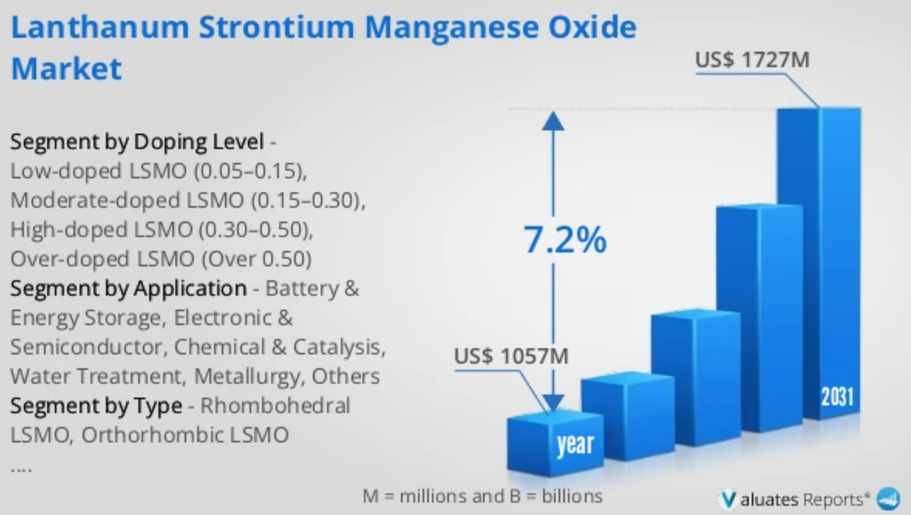
(https://reports.valuates.com/market-reports/QYRE-Auto-12X20236/global-lanthanum-strontium-manganese-oxide)
- The major global manufacturers of Lanthanum Strontium Manganese Oxide include American Elements (USA), Nexceris (USA), Stanford Advanced Materials (USA), Cerpotech (Norway), Oerlikon Metco (Switzerland), TOB New Energy (China), Infinita Materials (USA), ATT Advanced Elements (USA), AbleTarget (China), ALB Materials (USA), etc. Have worldwide (including USA) suppliers.
Relationship Between LaMnO₃ and LSMO
- LaMnO₃ is the parent compound of the perovskite manganite family.
- LSMO is the strontium-doped derivative where strontium ions (Sr²⁺) replace a fraction of lanthanum ions (La³⁺) within the same crystal lattice.
Because LSMO is produced at a kiloton scale (approx. 42,000 tons/year) for fuel cell cathodes, the supply chain for the base LaMnO₃ chemistry is already fully mature.
- Industrial facilities capable of mass-producing LSMO can switch to pure LaMnO₃ production with zero hardware reconfiguration, simply by omitting the strontium dopant.

